**College of Engineering, Pune**

Dept. of Electronics and Telecommunication Engineering

**SY MICRO PROJECT – 2021-22**

**PROJECT NAME –** Automatic Sun Tracking System

(Using Arduino UNO)

**DONE BY: -** 1) GURUPRASAD DHORE - 112007020

2) PRAJWAL DESHMUKH-112007017

3) RAM DHALPE - 112007018

4) MITHIL DHARMIK - 112007019

**GUIDED BY: -** Prof. YOGITA KAPSE

|  |  |  |
| --- | --- | --- |
| **1** | **Abstract** |  |
| **2** | **Introduction** |  |
| **3** | **Problem Analysis** |  |
| **4** | **Block Diagram** |  |
| **5** | **Review of Literature** |  |
| **6** | **Implementation** |  |
| **7** | **Algorithm and Code** |  |
| **8** | **Result** |  |
| **9** | **Advantages** |  |
| **10** | **Conclusion** |  |
| **11** | **Reference** |  |

**CONTENTS**

**ABSTRACT**

A typical solar panel converts only 30 to 40 percent of the incident solar irradiation into electrical energy. Thus, to get a constant output, an automated system is required which should be capable to constantly rotate the solar panel. The Sun Tracking System (STS) was made as a prototype to solve the problem, mentioned above. It is completely automatic and keeps the panel in front of sun until that is visible. The unique feature of this system is that instead of taking the earth as its reference, it takes the sun as a guiding source. Its active sensors constantly monitor the sunlight and rotate the panel towards the direction where the intensity of sunlight is maximum. With the rapid increase in population and economic development, the problems of the energy crisis and global warming effects are today a cause for increasing concern. The utilization of renewable OPEN ACCESS Sensors 2013, 13 3158 energy resources is the key solution to these problems. Solar energy is one of the primary sources of clean, abundant and inexhaustible energy, that not only provides alternative energy resources, but also improves environmental pollution. The most immediate and technologically attractive use of solar energy is through photovoltaic conversion. The physics of the PV cell (also called solar cell) is very similar to the classical p-n junction diode. The PV cell converts the sunlight directly into direct current (DC) electricity by the photovoltaic effect [1,2]. A PV panel or module is a packaged interconnected assembly of PV cells. In order to maximize the power output from the PV panels, one needs to keep the panels in an optimum position perpendicular to the solar radiation during the day. As such, it is necessary to have it equipped with a Sun tracker. Compared to a fixed panel, a mobile PV panel driven by a Sun tracker may boost consistently the energy gain of the PV panel.

**INTRODUCTION**

As the non-renewable energy resources are decreasing, use of renewable resources for producing electricity is increasing. Solar panels are becoming more popular day by day. Solar panel absorbs the energy from the Sun, converts it into electrical energy and stores the energy in a battery.

This energy can be utilized when required or can be used as a direct alternative to the grid supply. Utilization of the energy stored in batteries is mentioned in below given applications.

The position of the Sun with respect to the solar panel is not fixed due to the rotation of the Earth. For an efficient usage of the solar energy, the Solar panels should absorb energy to a maximum extent.

This can be done only if the panels are continuously placed towards the direction of the Sun. So, solar panel should continuously rotate in the direction of Sun. This article describes about circuit that rotates solar panel.

**PRINCIPAL OF SOLAR TRACKING PANEL**

The Sun tracking solar panel consists of two LDRs, solar panel and a servo motor and ATmega328 Micro controller.

Two light dependent resistors are arranged on the edges of the solar panel. Light dependent resistors produce low resistance when light falls on them. The servo motor connected to the panel rotates the panel in the direction of Sun. Panel is arranged in such a way that light on two LDRs is compared, and panel is rotated towards LDR which have high intensity i.e., low resistance compared to other. Servo motor rotates the panel at certain angle.

When the intensity of the light falling on right LDR is more, panel slowly moves towards right and if intensity on the left LDR is more, panel slowly moves towards left. In the noon time, Sun is ahead and intensity of light on both the panels is same. In such cases, panel is constant and there is no rotation.

**BLOCK DIAGRAM**

**REVIEW OF LITERATURE**

**a) Hardware Interface:**

Solar Panel: - Solar panel refers to a panel designed to absorb the sun's rays as a source of energy for generating electricity or heating. Photovoltaic modules use light energy (photons) from the Sun to generate electricity through the photovoltaic effect. Most modules use wafer-based crystalline silicon cells or thin-film cells. The structural (load carrying) member of a module can either be the top layer or the back layer. Cells must also be protected from mechanical damage and moisture. Most modules are rigid, but semi-flexible ones are available, based on thin-film cells. The cells must be connected electrically in series, one to another. Externally, most of photovoltaic modules use MC4 connectors type to facilitate easy weatherproof connections to the rest of the system. Modules electrical connections are made in series to achieve a desired output voltage and/or in parallel to provide a desired current capability. The conducting wires that take the current off the modules may contain silver, copper or other non-magnetic conductive transition metals. Bypass diodes may be incorporated or used externally, in case of partial module shading, to maximize the output of module sections still illuminated.

**Fig.1 Solar Panel**

Arduino UNO Microcontroller: -

Arduino is an open source, computer hardware and software company, project, and user community that designs and manufactures microcontroller kits for building digital devices and interactive objects that can sense and control objects in the physical world. The project's products are distributed as open-source hardware and software, which are licensed under the GNU Lesser General Public License (LGPL) or the GNU General Public License (GPL) permitting the manufacture of Arduino boards and software distribution by anyone. Arduino boards are available commercially in preassembled form, or as do-it yourself kits. Arduino board designs use a variety of microprocessors and controllers. The boards are equipped with sets of digital and analog input/output (I/O) pins that may be interfaced to various expansion boards (shields) and other circuits. The boards feature serial communications interfaces, including Universal Serial Bus (USB) on some models, which are also used for loading programs from personal computers. The microcontrollers are typically programmed using a dialect of features from the programming languages C and C++. In addition to using traditional compiler toolchains, the Arduino project provides an integrated development environment (IDE) based on the Processing language project.

Arduino UNO: - The Arduino Uno is an open-source microcontroller board based on the Microchip ATmega328P microcontroller and developed by Arduino.cc. The board is equipped with sets of digital and analog input/output (I/O) pins that may be interfaced to various expansion boards and other circuits. The board has 14 digital I/O pins (six capable of PWM output), 6 analog I/O pins, and is programmable with the Arduino IDE (Integrated Development Environment), via a type B USB cable. It can be powered by the USB cable or by an external 9-volt battery, though it accepts voltages between 7 and 20 volts. It is similar to the Arduino Nano and Leonardo.

**Fig.2 Arduino UNO board.**

LDRs: -

A Light Dependent Resistor (LDR) or a photo resistor is a device whose resistivity is a function of the incident electromagnetic radiation. Hence, they are light sensitive devices. They are also called as photo conductors, photo conductive cells or simply photocells. They are made up of semiconductor materials having high resistance. A photoresistor is made of a high resistance semiconductor. In the dark, a photoresistor can have a resistance as high as several megohms (MΩ), while in the light, a photoresistor can have a resistance as low as a few hundred ohms. If incident light on a photoresistor exceeds a certain frequency, photons absorbed by the semiconductor give bound electrons enough energy to jump into the conduction band. The resulting free electrons (and their hole partners) conduct electricity, thereby lowering resistance. The resistance range and sensitivity of a photoresistor can substantially differ among dissimilar devices. Moreover, unique photoresistors may react substantially differently to photons within certain wavelength bands.

**Fig. 3 Light Dependent Resistor (LDR)**

Servo Motors: - A servomotor is a rotary actuator or linear actuator that allows for precise control of angular or linear position, velocity and acceleration. It consists of a suitable motor coupled to a sensor for position feedback. It also requires a relatively sophisticated controller, often a dedicated module designed specifically for use with servomotors. Servomotors are not a specific class of motor although the term servomotor is often used to refer to a motor suitable for use in a closed-loop control system. A servomotor is a closed-loop servomechanism that uses position feedback to control its motion and final position. The input to its control is a signal (either analogue or digital) representing the position commanded for the output shaft. The motor is paired with some type of encoder to provide position and speed feedback. In the simplest case, only the position is measured. The measured position of the output is compared to the command position, the external input to the controller. If the output position differs from that required, an error signal is generated which then causes the motor to rotate in either direction, as needed to bring the output shaft to the appropriate position. As the positions approach, the error signal reduces to zero and the motor stops. The very simplest servomotors use position-only sensing via a potentiometer and bang-bang control of their motor; the motor always rotates at full speed (or is stopped). This type of servomotor is not widely used in industrial motion control, but it forms the basis of the simple and cheap servos used for radio-controlled models. More sophisticated servomotors use optical rotary encoders to measure the speed of the output shaft and a variable-speed drive to control the motor speed. Both of these enhancements, usually in combination with a PID control algorithm, allow the servomotor to be brought to its commanded position more quickly and more precisely, with less overshooting.

**Fig. 4 Servo Motor**

**b) Software Interface**

Arduino IDE:- A program for Arduino may be written in any programming language for a compiler that produces binary machine code for the target processor. Atmel provides a development environment for their microcontrollers, AVR Studio and the newer Atmel Studio. The Arduino project provides the Arduino integrated development environment (IDE), which is a cross-platform application written in the programming language Java. It originated from the IDE for the languages Processing and Wiring. It includes a code editor with features such as text cutting and pasting, searching and replacing text, automatic indenting, brace matching, and syntax highlighting, and provides simple one-click mechanisms to compile and upload programs to an Arduino board. It also contains a message area, a text console, a toolbar with buttons for common functions and a hierarchy of operation menus. A program written with the IDE for Arduino is called a sketch. Sketches are saved on the development computer as text files with the file extension. ino. Arduino Software (IDE) pre1.0 saved sketches with the extension. pde. The Arduino IDE supports the languages C and C++ using special rules of code structuring. The Arduino IDE supplies a software library from the Wiring project, which provides many common input and output procedures. User-written code only requires two basic functions, for starting the sketch and the main program loop, that are compiled and linked with a program stub *main()* into an executable cyclic executive program with the GNU toolchain, also included with the IDE distribution. The Arduino IDE employs the program *avrdude* to convert the executable code into a text file in hexadecimal encoding that is loaded into the Arduino board by a loader program in the board's firmware.

**IMPLEMENTATION DETAILS**

Schematic Diagram of Automatic sun Tracker:

**Fig. 5 Schematic of Sun tracker**

**CIRCUIT OPERATIONS**

1. LDRs are used as the main light sensors. Two servo motors are fixed to the structure that holds the solar panel. The program for Arduino is uploaded to the microcontroller. The working of the project is as follows.
2. LDRs sense the amount of sunlight falling on them. Four LDRs are divided into top, bottom, left and right.
3. For east – west tracking, the analog values from two top LDRs and two bottom LDRs are compared and if the top set of LDRs receive more light, the vertical servo will move in that direction.
4. If the bottom LDRs receive more light, the servo moves in that direction.
5. For angular deflection of the solar panel, the analog values from two left LDRs and two right LDRs are compared. If the left set of LDRs receive more light than the right set, the horizontal servo will move in that direction.
6. If the right set of LDRs receive more light, the servo moves in that direction.

**ALGORITHM AND CODE**

Algorithm –

Step1: Start

Step2: Initialise all necessary inputs and outputs to zero.

Step3: Assign analog LDR outputs and PWM servomotor inputs to Arduino Uno.

Step4: If LDR1 = LDR2, then delay (longer).

Step5: Check alignment (Simultaneously for east-west)

Step6: If up (LDR1) greater than down (LDR2), then increase position of servomotor 1 by 1 unit. Give delay.  
Step7: Else if up (LDR) lesser than centre and down (LDR) greater than centre, then decrease position of servomotor1 by 1 unit. Give delay.

Step8: (Simultaneously along with step6) If right (LDR) greater than centre and left (LDR) lesser than centre then increase the position of servomotor2 by 1 unit. Give delay.   
Step9: Else if right (LDR) is lesser than centre and left (LDR) greater than centre then decrease position of servomotor2 by 1 unit. Give delay.

Step10: Go to Step 5.

Step11: End.

**Flowchart**

**Fig. 6 Flowchart of algorithm**

**CODE**

#include <Servo.h> //includes the servo library

Servo myservo;

#define ldr1 A0 // set ldr 1 Analog input pin of East ldr as an integer

#define ldr2 A1 // set ldr 2 Analog input pin of West ldr as an integer

int pos = 90; // initial position of the Horizontal movement controlling servo motor

int tolerance = 20; // allowable tolerance setting - so solar servo motor isn't constantly in motion

void setup(){

myservo.attach(2); // attaches the servo on digital pin 2 to the horizontal movement servo motor

pinMode(ldr1, INPUT); //set East ldr pin as an input

pinMode(ldr2, INPUT); //set West ldr pin as an input

myservo.write(pos); // write the starting position of the horizontal movement servo motor

delay(1000); // 1 second delay to allow the solar panel to move to its staring position before comencing solar tracking

}

void loop(){

int val1 = analogRead(ldr1); // read the value of ldr 1

int val2 = analogRead(ldr2); // read the value of ldr 2

if((abs(val1 - val2) <= tolerance) || (abs(val2 - val1) <= tolerance)) {

//no servo motor horizontal movement will take place if the ldr value is within the allowable tolerance

}else {

if(val1 > val2) // if ldr1 senses more light than ldr2

{

pos = pos+1; // decrement the 90 degree poistion of the horizontal servo motor - this will move the panel position Eastward

}

if(val1 < val2) // if ldr2 senses more light than ldr1

{

pos = pos-1; // increment the 90 degree position of the horizontal motor - this will move the panel position Westward

}

}

if(pos > 180) {pos = 180;} // reset the horizontal postion of the motor to 180 if it tries to move past this point

if(pos < 0) {pos = 0;} // reset the horizontal position of the motor to 0 if it tries to move past this point

myservo.write(pos); // write the starting position to the horizontal motor

delay(50);

}

**RESULT**

**Fig. 7 Project result picture**

**Technical Evaluation**

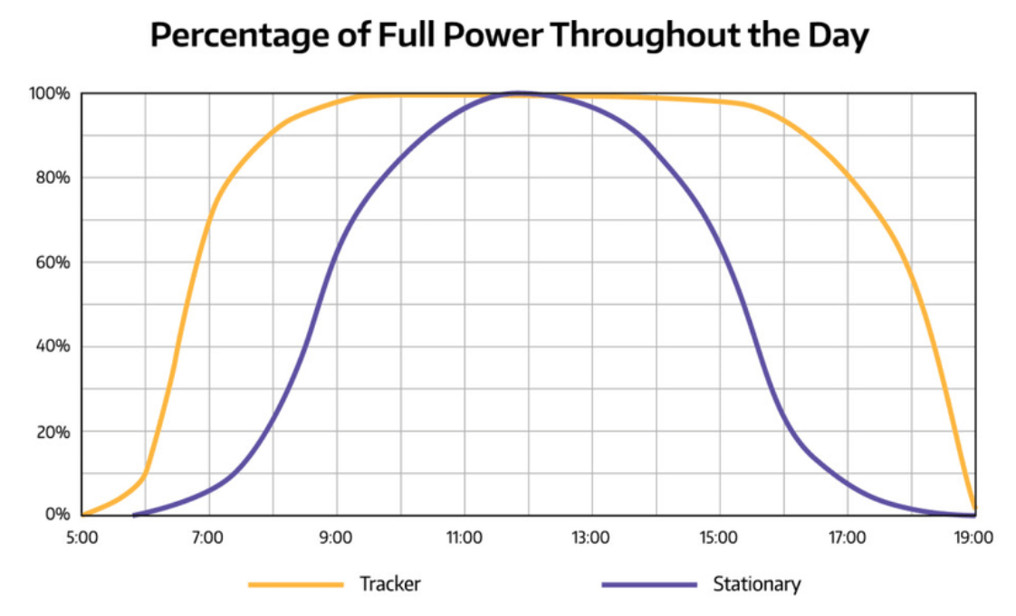

**Fig. 8 Graph comparison of Tracker and stationary solar panels.**

**ADVANTAGES:**

* This automatic solar tracker is easy to implement since its construction is simple.
* With the implementation the proposed system the additional energy generated is around 25% to 30% with very less consumption by the system itself.
* The solar panel with the sun in order to extract maximum energy falling on it renewable energy is rapidly gaining importance as an energy resource as fossil fuel prices fluctuate.

**APPLICATIONS:**

* This system software and hardware can be used to drive a real and very huge solar panel.
* The computer and System Control Unit would have a wireless communication with the mechanical structure of solar panel.

**CONCLUSION:**

As single-axis tracking generates more power from each panel, you can achieve the same power output with fewer panels, frames and so on, which reduces a project's upfront costs and offsets to a great extent the additional cost for tracking hardware. On the other hand, you can use the same number of panels as originally planned and generate more power and higher revenues. This reduces the project's payback time and increases the overall return on investment (ROI), depending on the financial specifics of the project. Solar radiation Tracker has played a vital role in increasing the efficiency of solar panels in recent years, thus proving to be a better technological achievement. The vital importance of a single axis solar tracker lies in its better efficiency and sustainability to give a better output compared to a fixed solar panel. Hence, maximum possible energy is trapped throughout the day as well as throughout the year. Thus, the output increases indicating that the efficiency more than a fixed solar panel (about 30 -40% more).

**REFERENCES**

[1] <https://www.researchgate.net/publication/312113501_A_sensorless_MPPT-based_solar_tracking_control_approach_for_mobile_autonomous_systems#pf2>

[2] <https://create.arduino.cc/projecthub/embeddedlab786/arduino-based-sun-tracking-solar-panel-03ad3f>

[3] Nikesh.D.Watane Rakesh.A.Dafde. AUTOMATIC SOLAR TRACKER SYSTEM. International Journal of Scientific & Engineering Research, Volume 4, Issue 6, June-2013. ISSN 2229-5518